**Assignment -2**

**Python Programming**

| Assignment Date | 29 September 2022 |
| --- | --- |
| Student Name | Roshitha R |
| Student Roll Number | 311119205043 |
| Maximum Marks | 2 Marks |

**1 & 2) Download and Load the dataset**

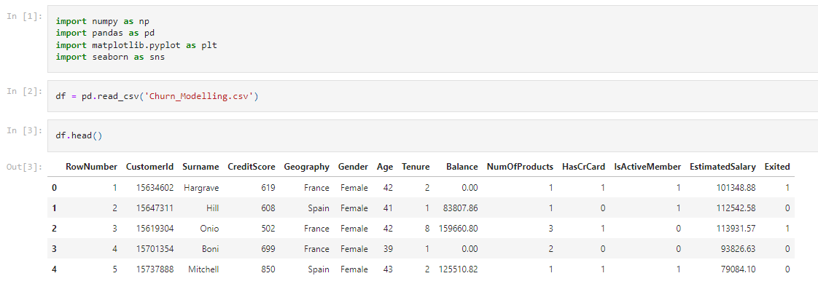

**3.1) Univariate Analysis**

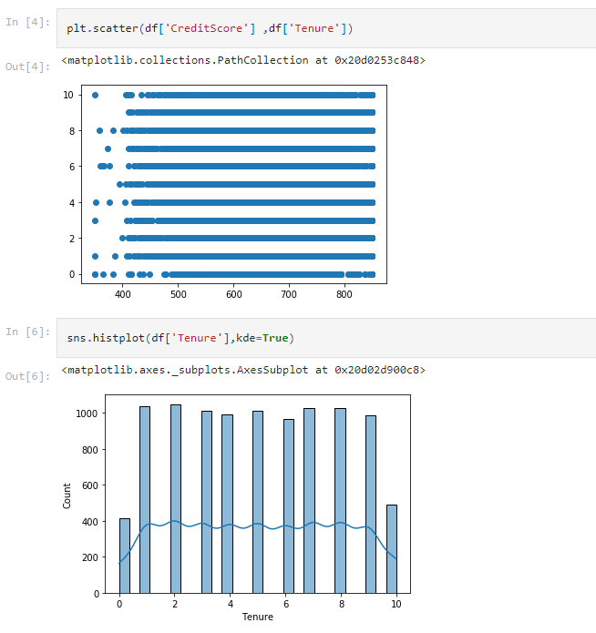

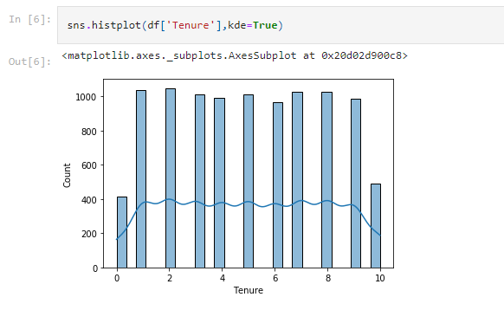

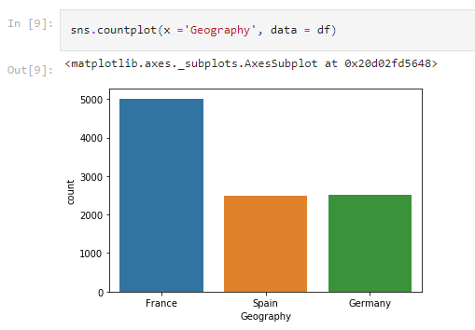

**3.2) Bivariate Analysis**

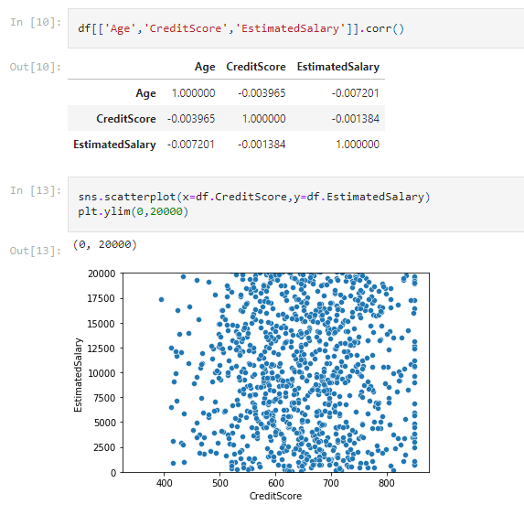

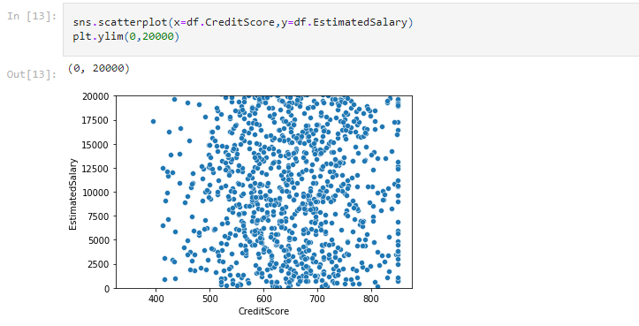

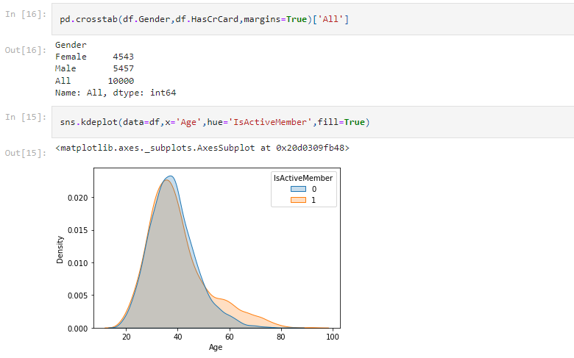

**3.3) Multivariate Analysis**

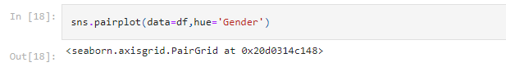

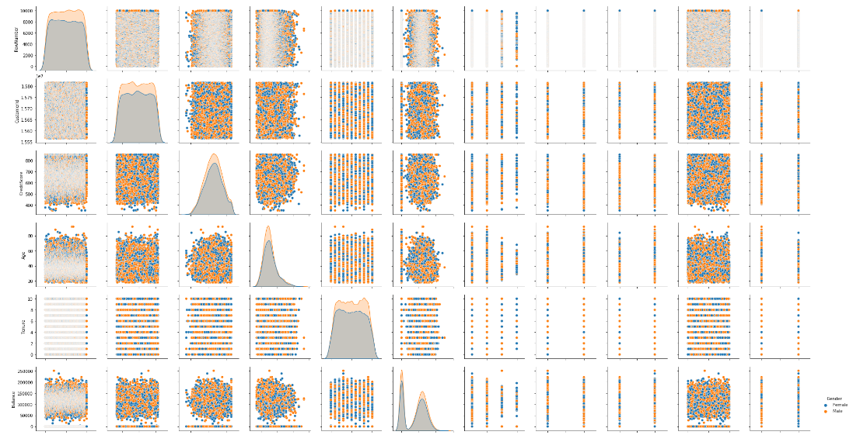

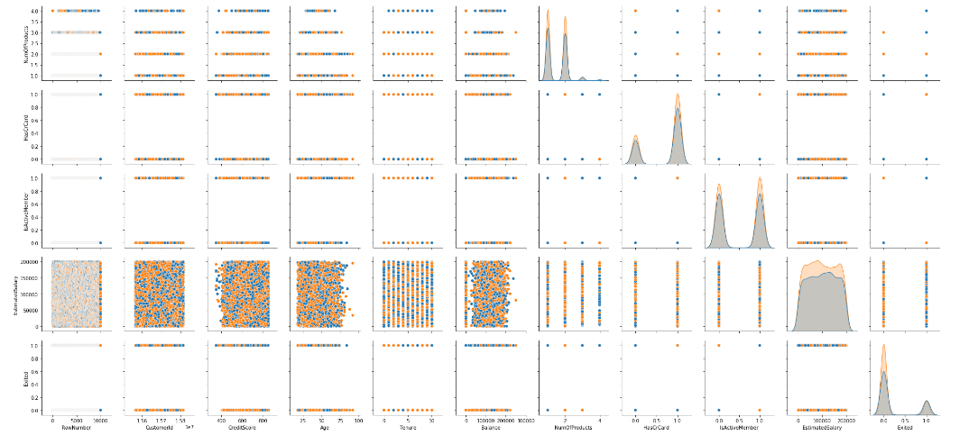

**4) Perform descriptive statistics on the dataset**

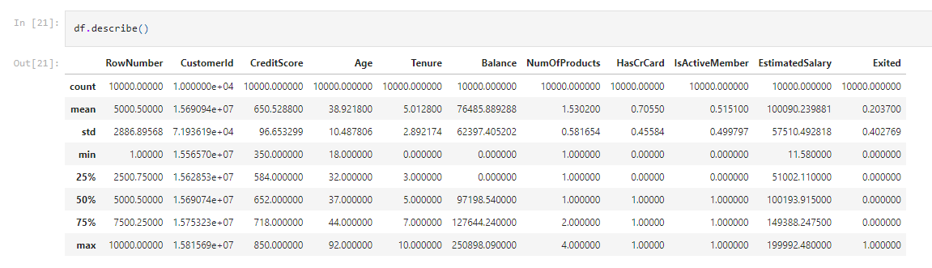

**5) Handle the Missing values**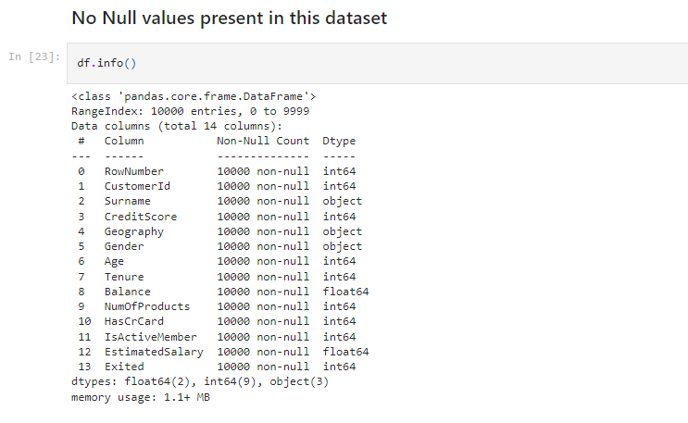

**6) Find the outliers and replace the outliers**

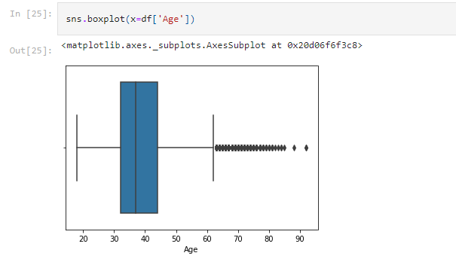

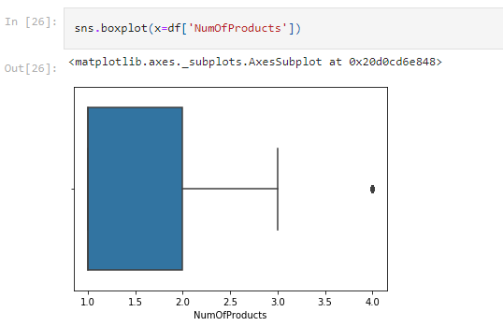

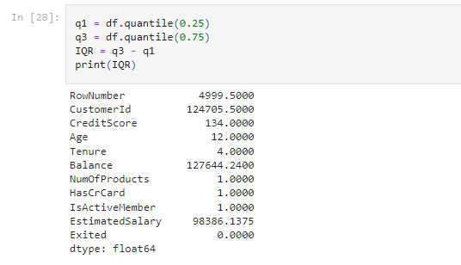

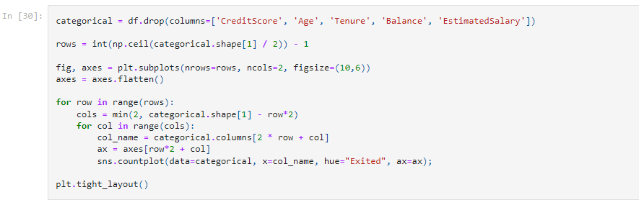

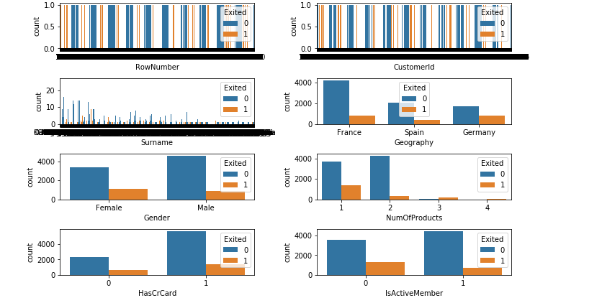

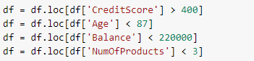

**7) Check for Categorical columns and perform encoding**

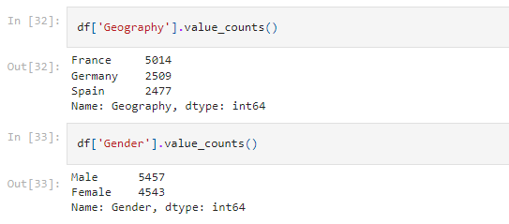

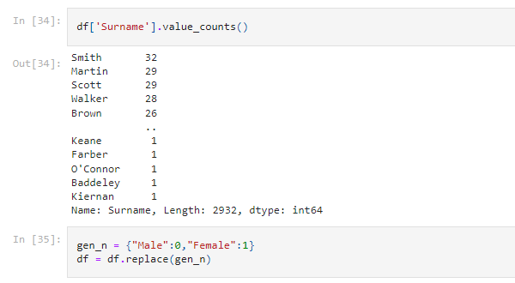

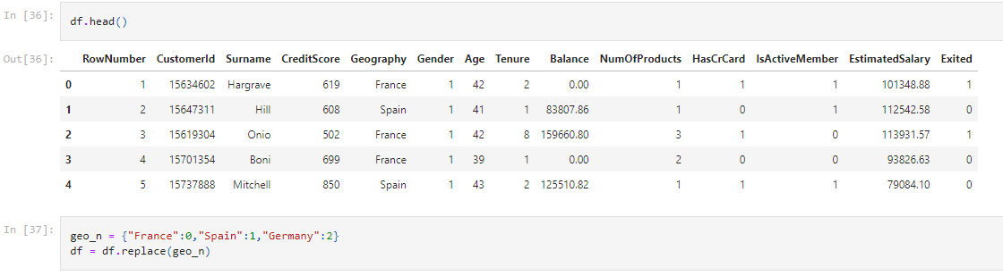

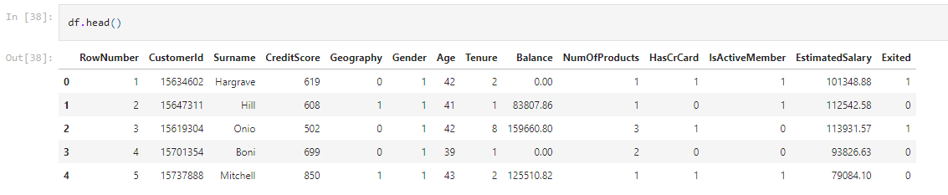

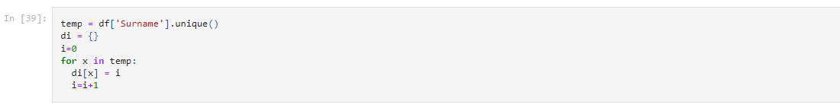

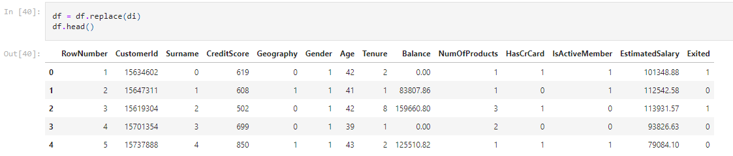

**8) Split the data into dependent and independent variables**



**9) Scale the independent variables**

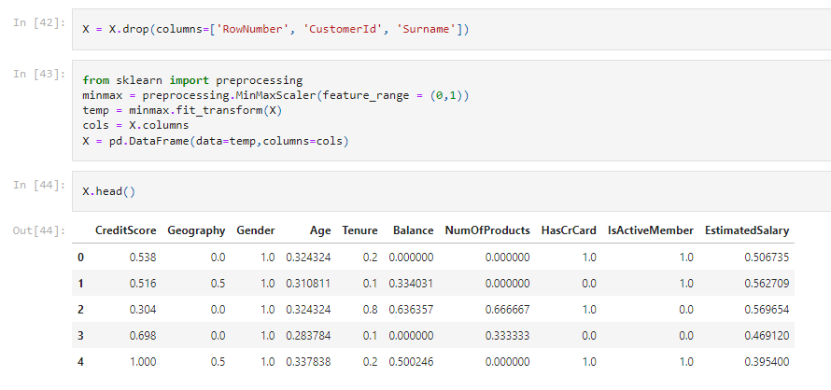

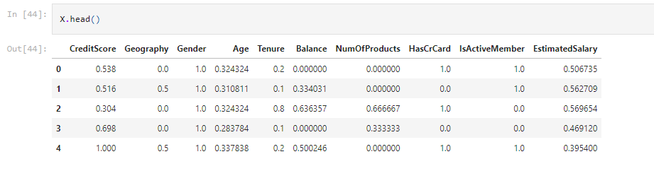

**10) Split the data into training and testing**

